**What has been Accomplished so far:**

**Facebook:**

Logging in using the Facebook SDK has been fully implemented. In addition a user’s public timeline and posts they are tagged in have been fully implemented (with a filter to remove errored posts). Sharing to a user’s wall ran into some issues, but is now able to post text messages (see photos). The settings and about pages have been integrated into the home screen (see embedded facebook timeline screenshot).

**Twitter:**

The bugs with Twitter login have finally been worked out and the complete OAuth flow has been written up in Javascript with a PHP backend. While functionality like adding media to tweets is very much in its infancy, the majority of the Twitter side is accessible on the frontend. User profiles and home timelines are visible and asynchronously update every minute with standard Twitter widgets embedded into the page (see photos for reference). Support for notifications is also in place, but is currently not visible due to there not being a standard for embedding them. We will develop custom elements for these in the near future.

**What we are behind on:**

We are slightly behind on implementations of the Twitter and Facebook backends, however since we were ahead on settings, we are still on schedule time wise. As far as Twitter goes, the most undeveloped side of it is the posting of tweets, which will be done soon.

**What we are ahead on:**

Nothing, we are on schedule.

**Whats next:**

Next will be integrating the Facebook and Twitter frontend and backend together and working out any kinks. While a large chunk of that is done, there are a few finer details and code refactors that we hope to accomplish. After that we will attempt to get sharing to multiple social medias working, as well as clean up the UI.

**Photos:**

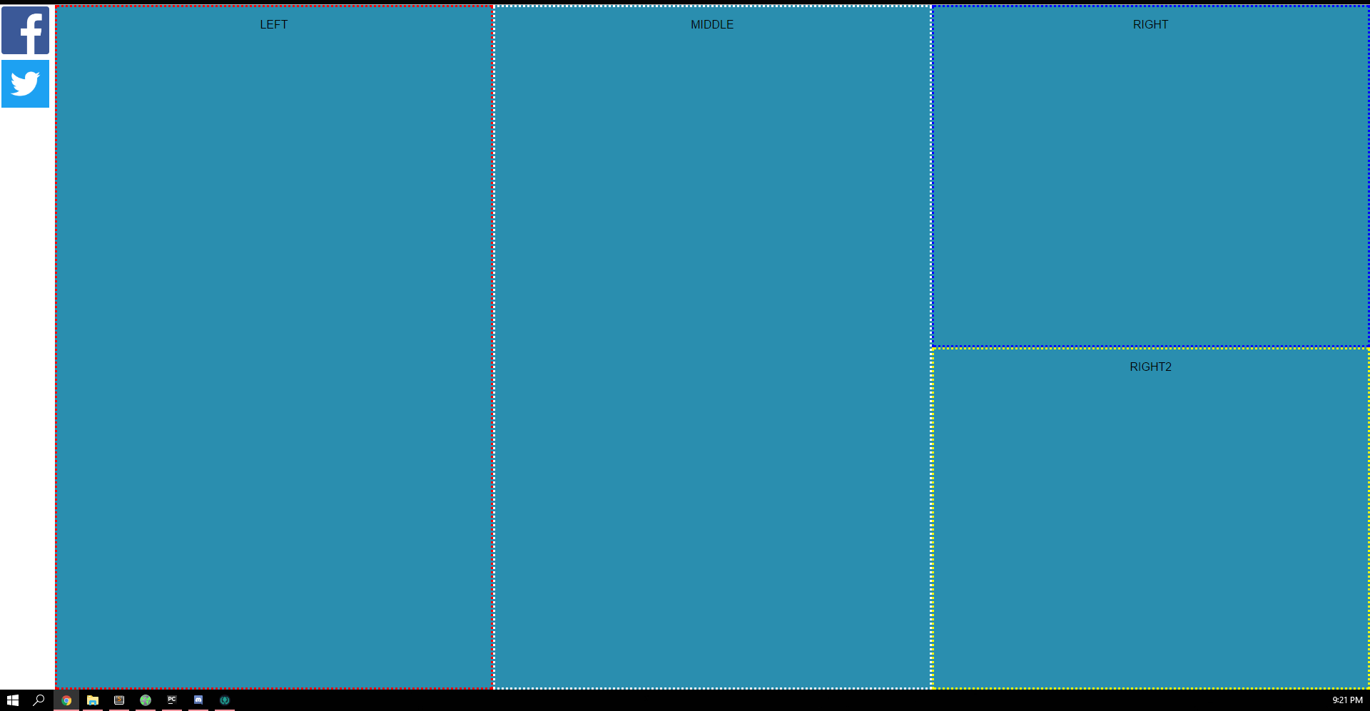

*The Home Page (Borders are just for show)*

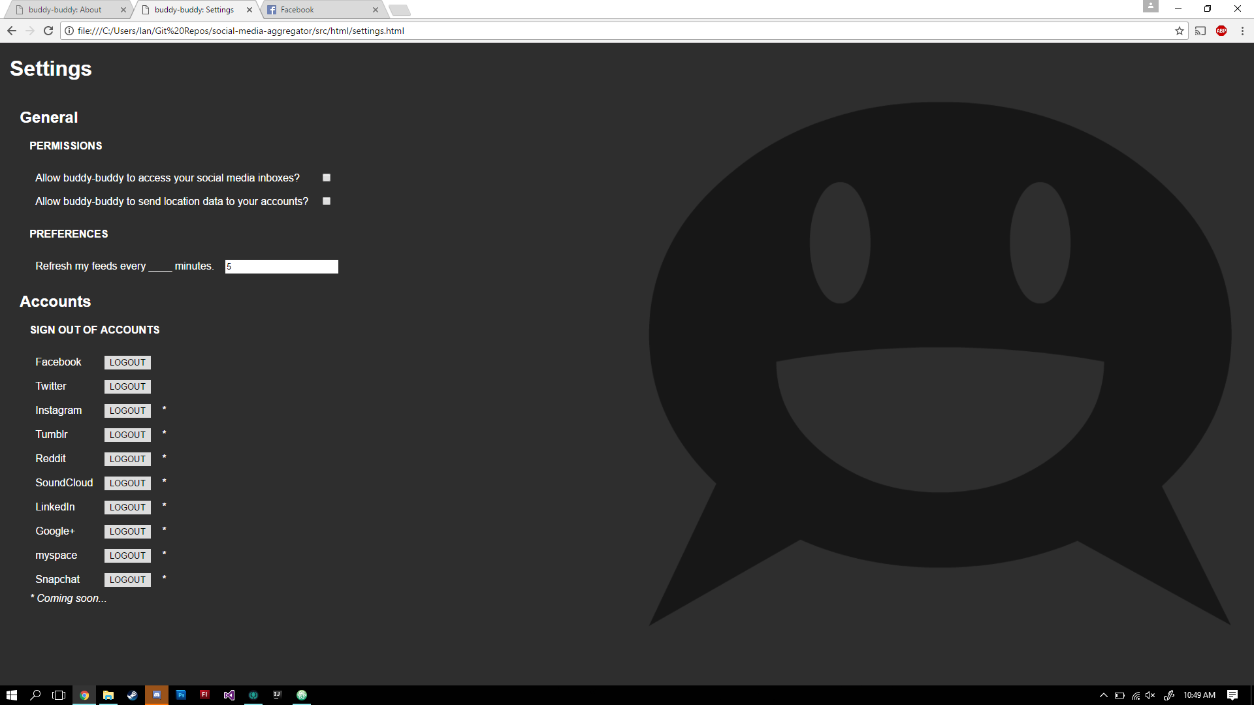

*Settings Page (first draft)*

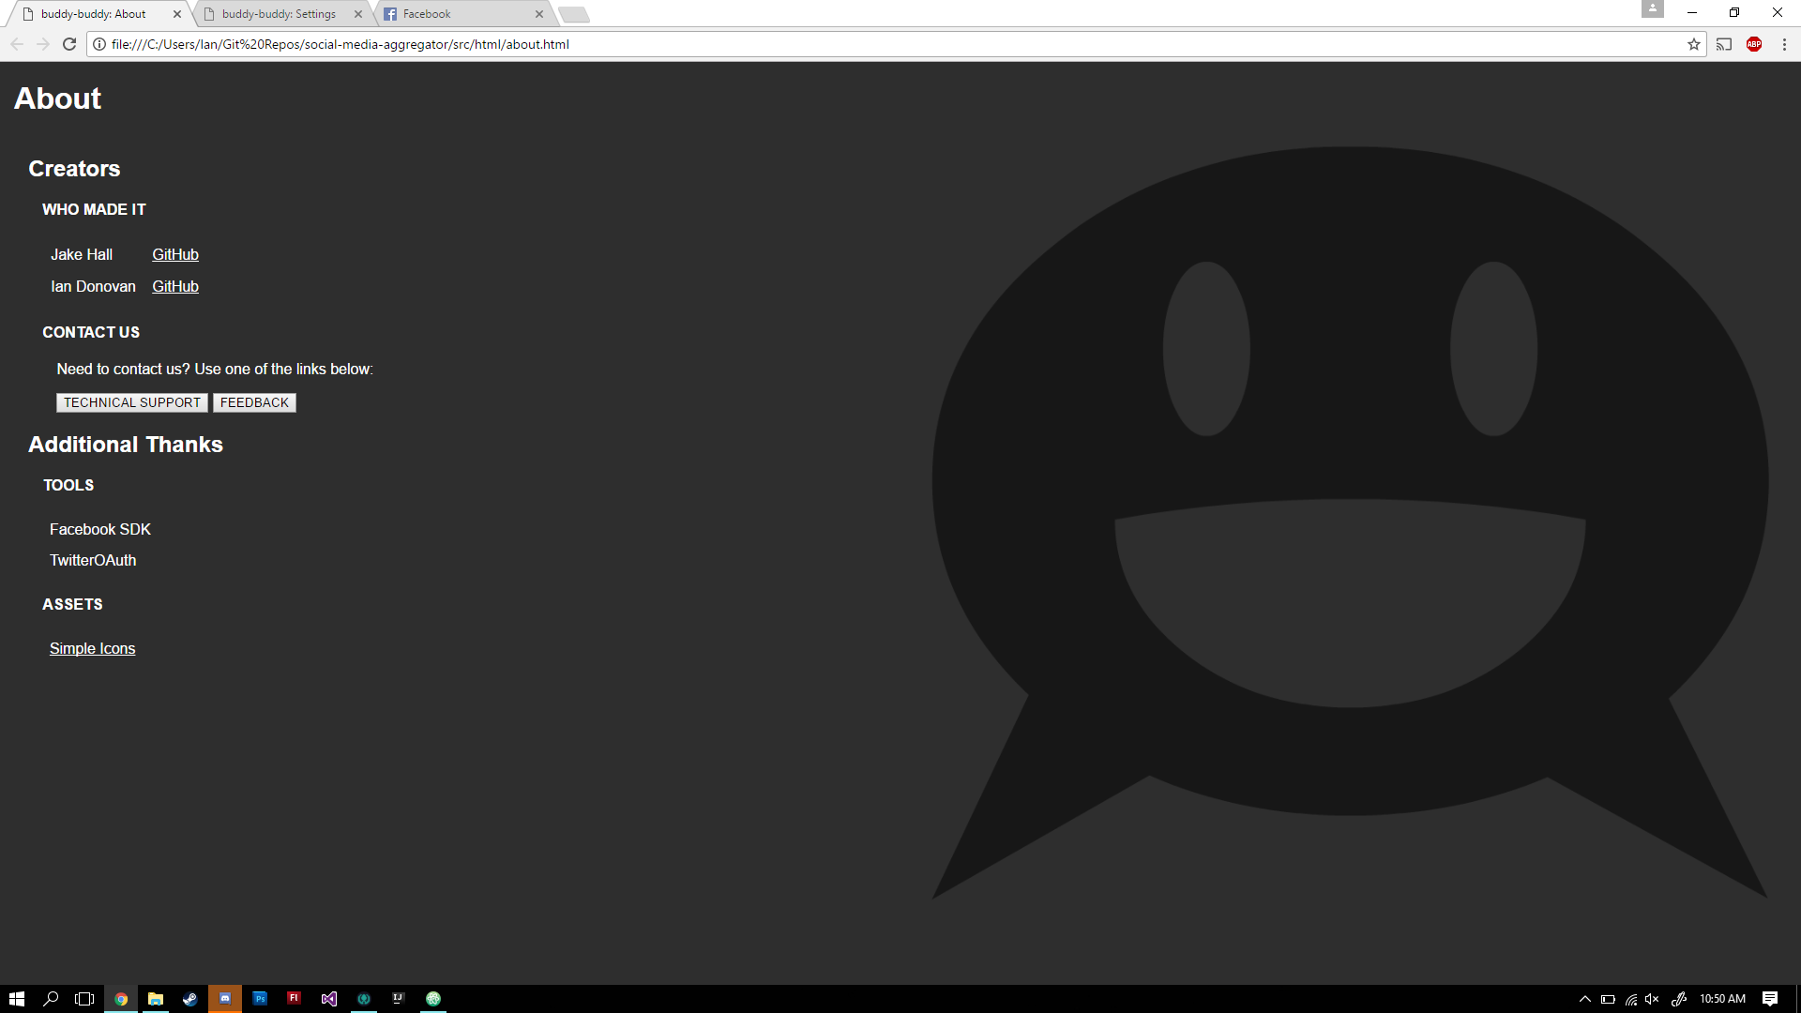

*About Page (first draft)*

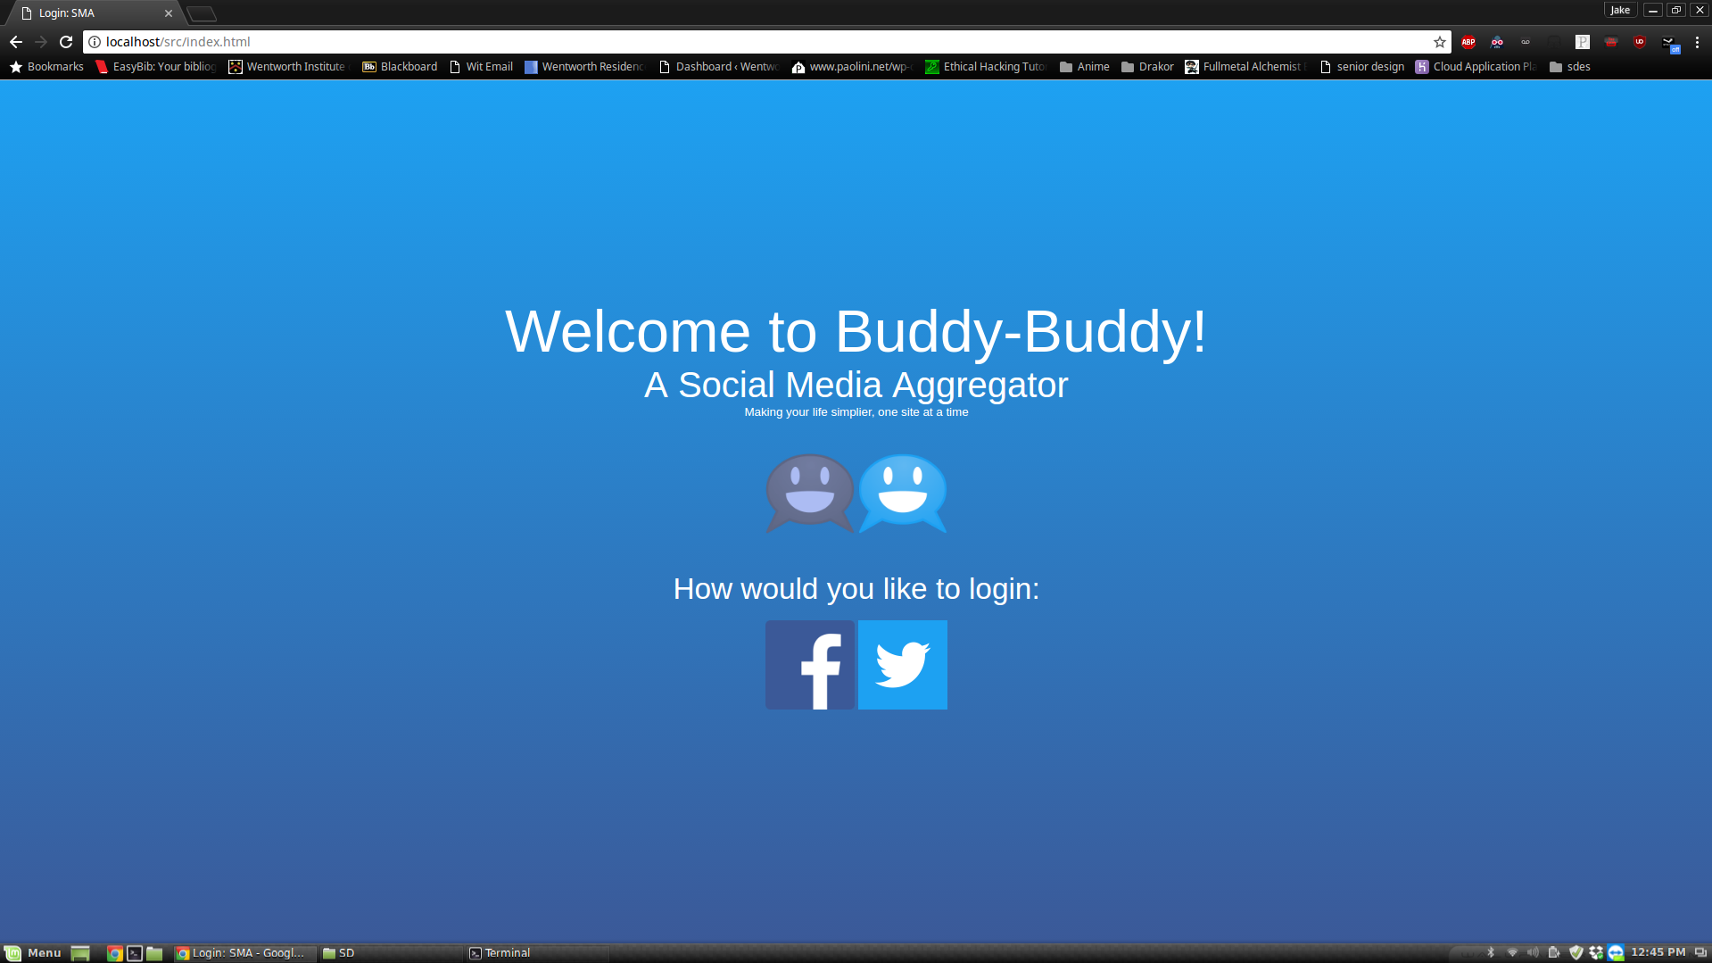

*The General Login Screen*

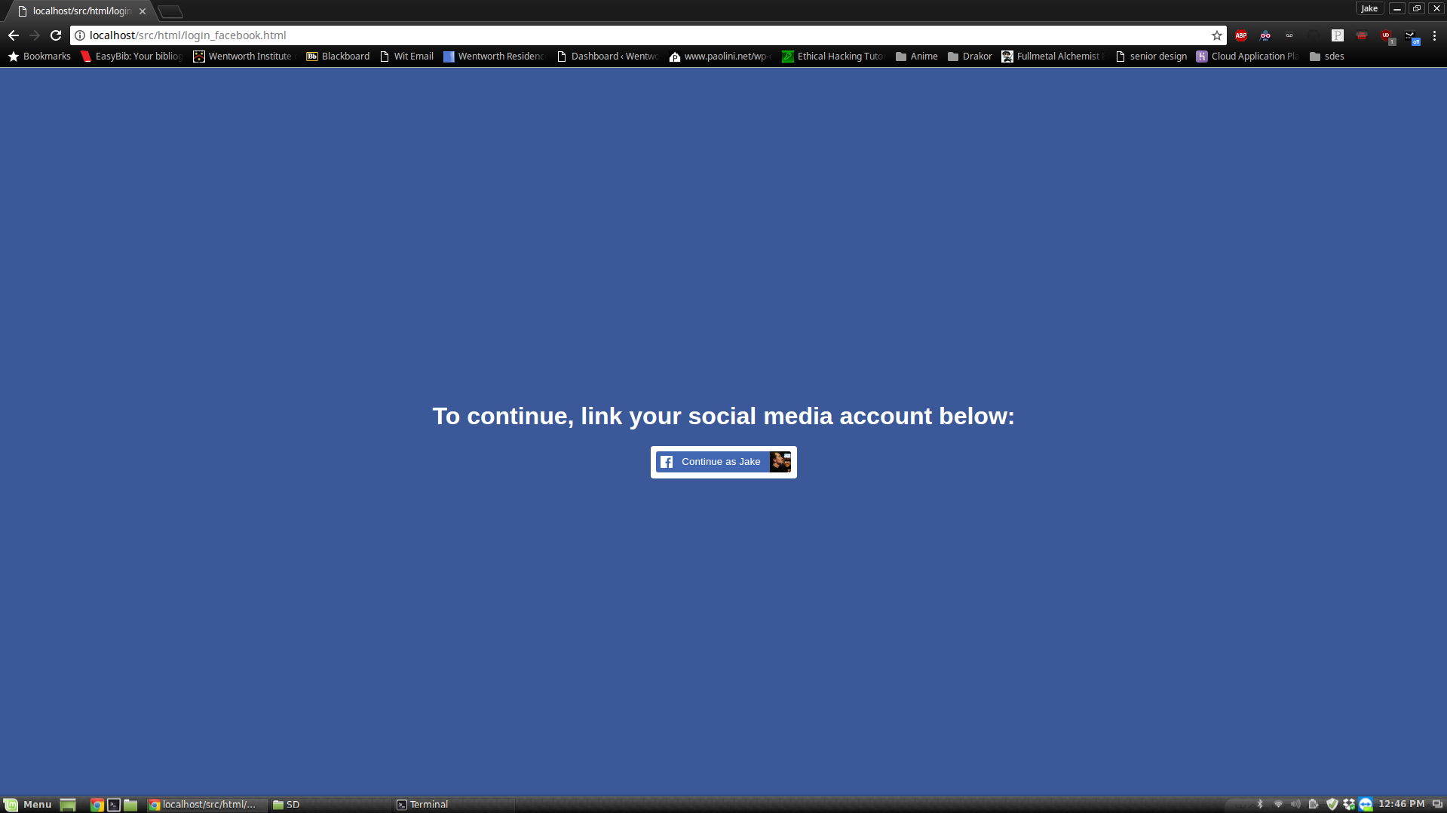

*The Facebook Specific Login Page*

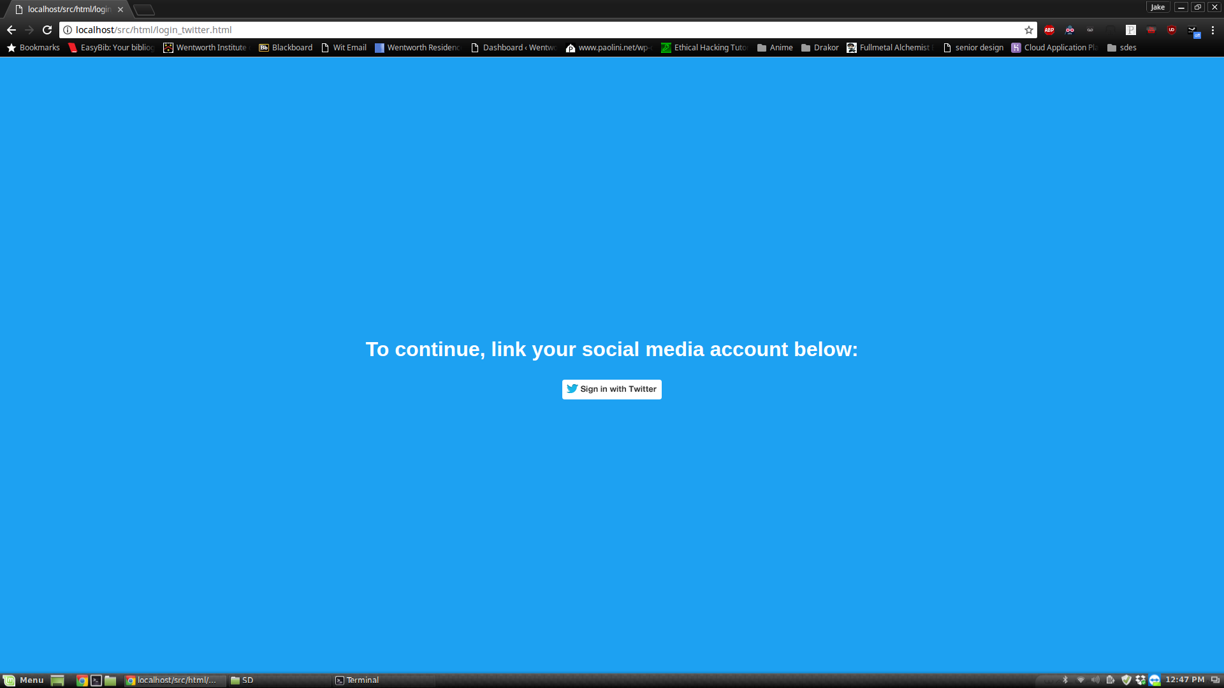

*The Twitter Specific Login Page*

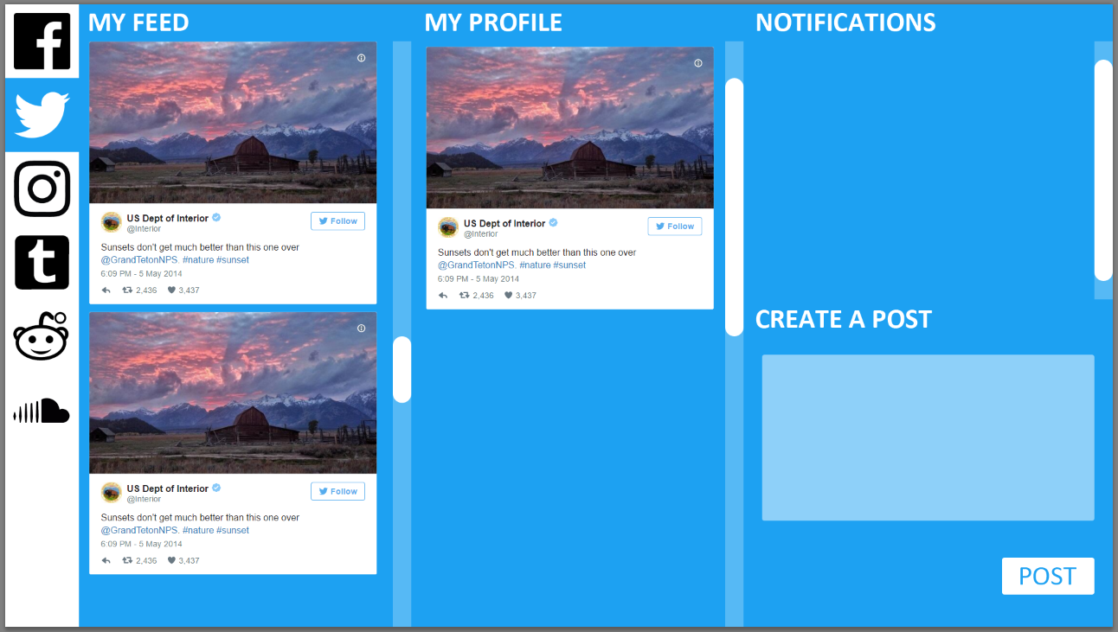

*Twitter Home Screen Mockup*

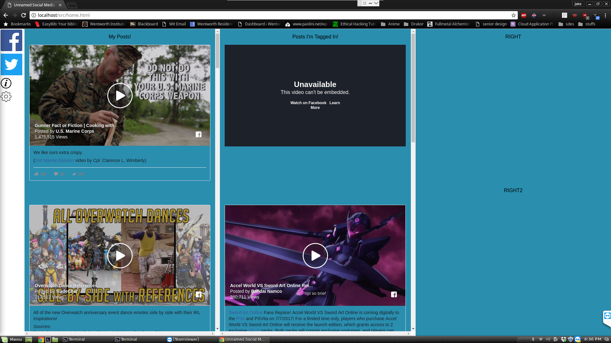

*Embedded facebook timeline*

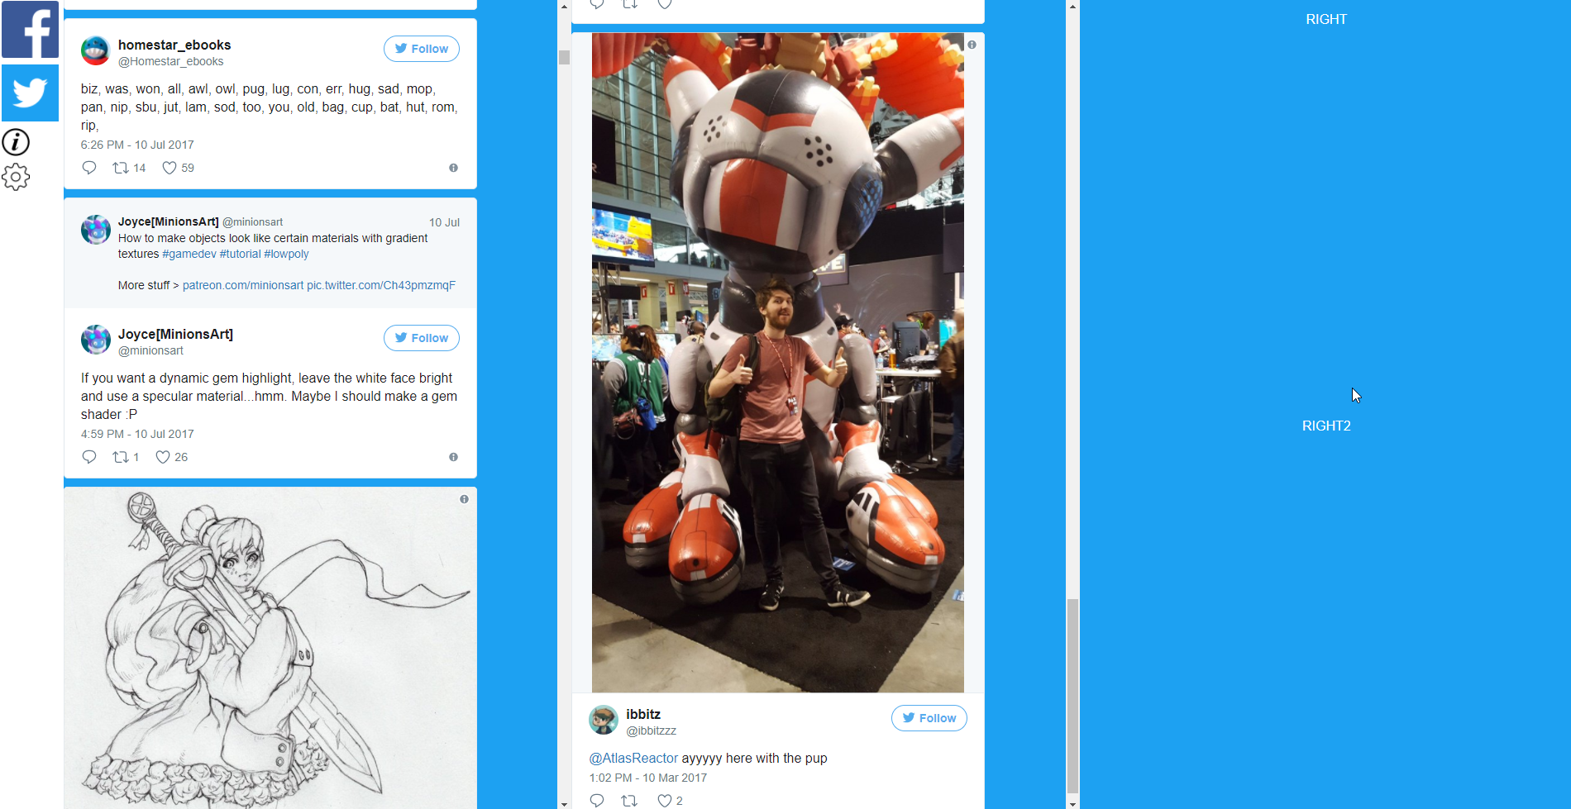

*Embedded Twitter timeline*

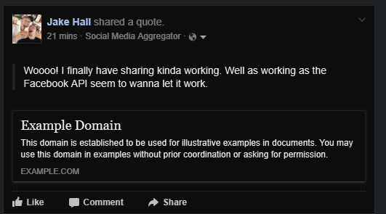

*A post shared from SMA*